Whether you are exploring majors or searching for information about your chosen field, The What Can I Do with This Major website will help you connect majors to careers. Learn about typical career areas and types of employers that hire people with each major, as well as strategies to make you a more marketable candidate.
You can reach the website in these simple steps:
• Go to http://www.shsu.edu/dept/career-services/
• Click on Students
• Click on What Can I Do With This Major
• Click on View All Majors
• Look for the Major you want to know more about and let the research begin! Make sure to look at the links at the bottom of each page for more information!

You can discuss choices of major with your academic advisor. For help with resumes, job searching, interview preparation, and general career information, SHSU Career Services is here for you!

Online Career Research Tools
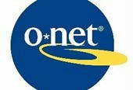
- https://www.onetonline.org/ -- The nation's primary source of occupational information. The O*NET database contains hundreds of standardized and occupation-specific descriptors on almost 1,000 occupations covering the entire U.S. economy. The database is continually updated from input by a broad range of workers in each occupation.
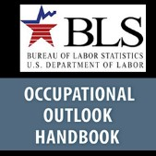
- https://www.bls.gov/ooh/ -- An online publication that has information on hundreds of occupations in the United States. The OOH is a rich resource for those seeking career guidance. Students can access valuable occupational information that can help them make career choices.

- https://www.shsu.edu – Check out the SHSU website and look at each major’s department website and curriculum and degree plans. It is important to inform yourself about the coursework before you make a decision regarding a major.
- https://www.careeronestop.org/ -- Resources and videos about careers, training, and job searching.

- https://joinhandshake.com -- BEARKATS GET HIRED partnered with Handshake. Handshake is the #1 way college students find jobs. Join today to explore career options, find jobs and internships for students, and connect with employers. Used by over 700 universities nationwide!

Remember SHSU Career Services is here to help you develop career readiness. We provide career information, resume critiques, mock interviews, help with LinkedIn and Handshake. We also offer career fairs and events throughout the academic year. For an appointment, find us on Campus Connect under Student Resources or call our Career Services Welcome Desk at 936-294-1713.

